# Team: The Circuit Breakers

**Alexander, Olivier, Jochem & Igor**

# 

# **Wifi**: Itenium2025 / DenBerg1840! (Gateway: 172.16.10.254, Subnet: 255.255.25**2**.0)

# Team: Fried Chips Anonymous

**Bert Maes, Steven, Bert Vermorgen & Joris**

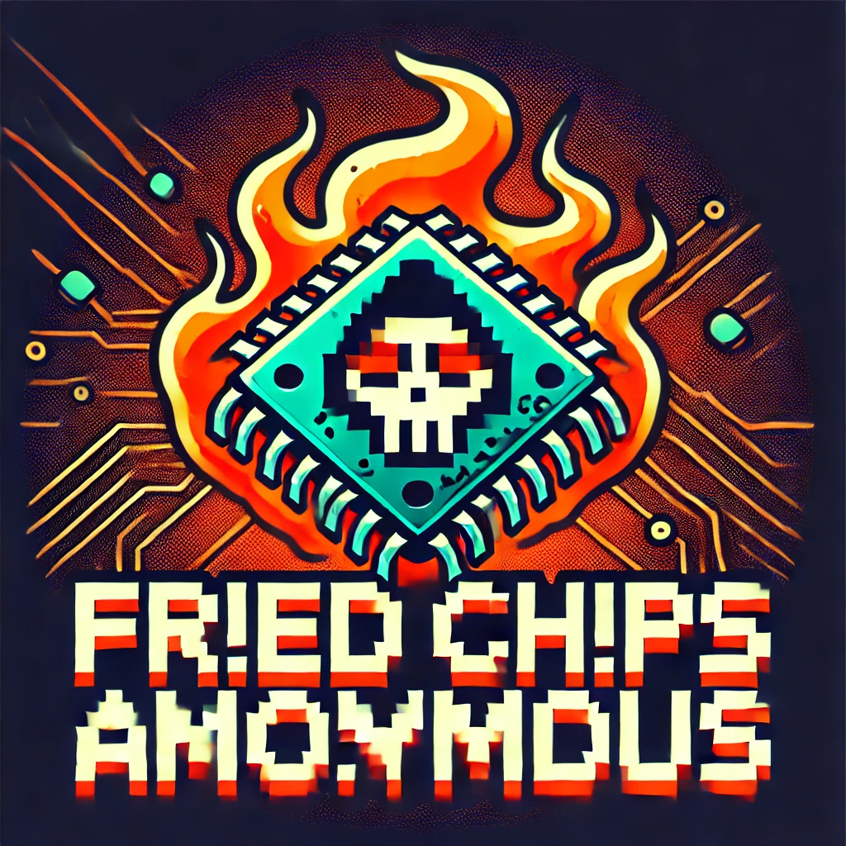

# **Wifi**: Itenium2025 / DenBerg1840! (Gateway: 172.16.10.254, Subnet: 255.255.25**2**.0)

# Team: Burnt Fingers Club

**Michael Dumortier, Michael Branders, Onur & Yannick**

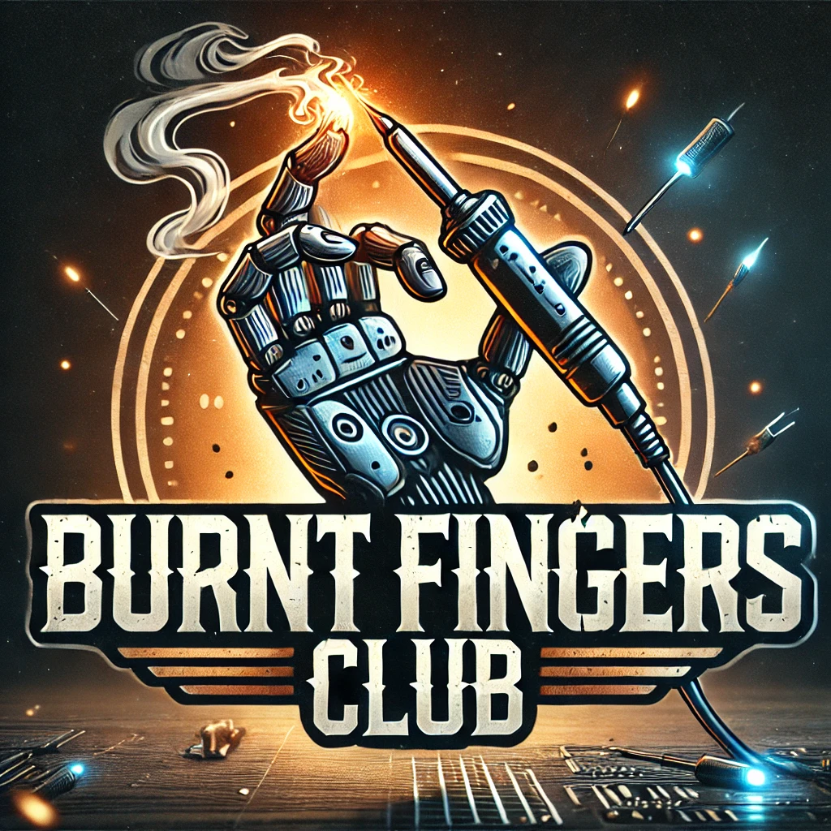

# **Wifi**: Itenium2025 / DenBerg1840! (Gateway: 172.16.10.254, Subnet: 255.255.25**2**.0)

# Team: Sparks but No Ragrets

**Tom Marroyen, Jelle, Nicolas, Pierre & Thomas De Brauwer**

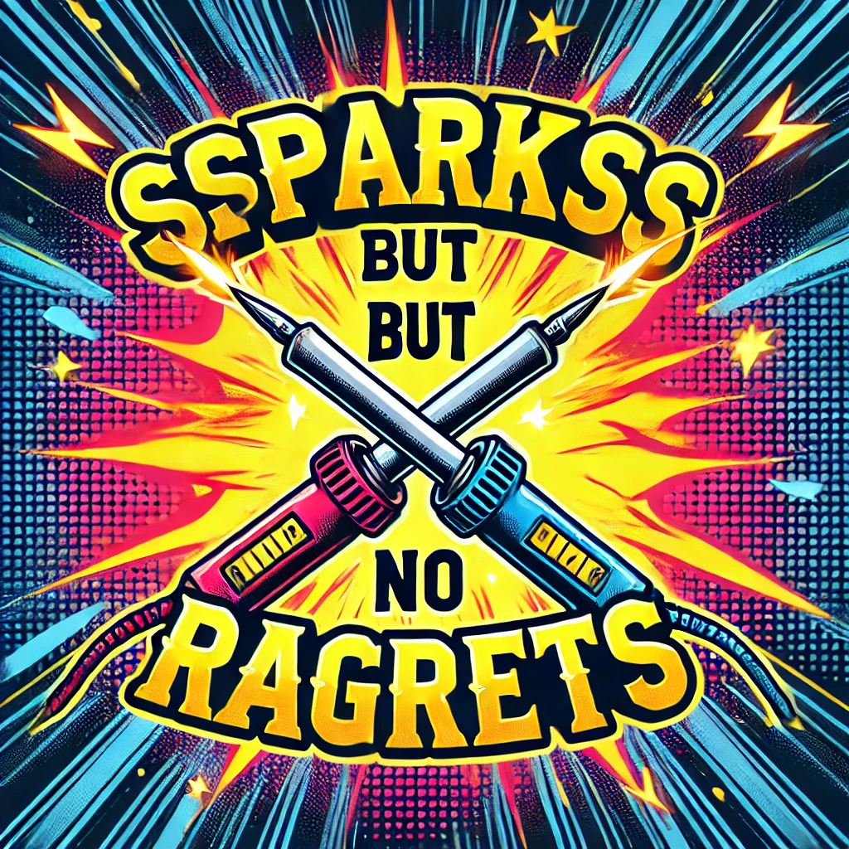

# **Wifi**: Itenium2025 / DenBerg1840! (Gateway: 172.16.10.254, Subnet: 255.255.25**2**.0)

# Team: The Sparkonauts

**Thomas Janssens, Heleen, Nina & Tom Vanacker**

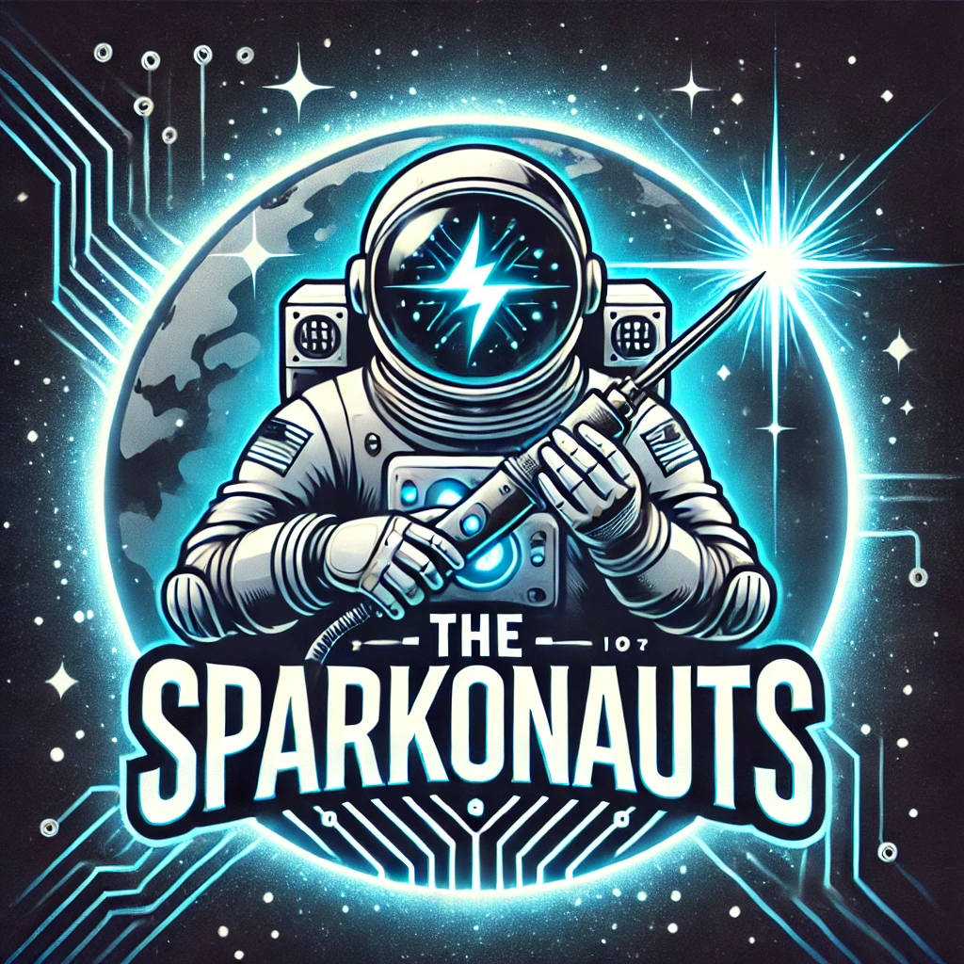

# **Wifi**: Itenium2025 / DenBerg1840! (Gateway: 172.16.10.254, Subnet: 255.255.25**2**.0)